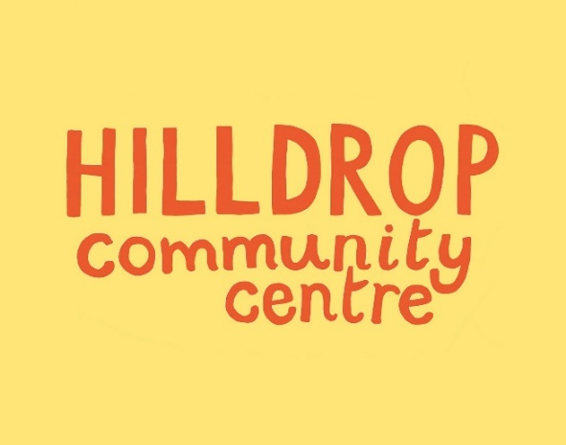
Our spaces are ideal for weekend children’s parties and family gatherings.
Children’s Parties at Hilldrop

£50 p/h

Our Main Hall
- Spacious hall, 137sq metres
- Holds 50-60 guests
- Garden space
- Food prep and serving area
Available Saturdays 12 – 7pm and Sundays 12-5.30pm

For more information or to book visit:
www.hilldrop.org.uk/hall-hire
or call 020 7607 9453
(weekdays after school parties: call to check availability)

Full details on our website: www.hilldrop.org/hallhire
Enquiries: 0207 607 9453 office@hilldrop.org.uk
Hilldrop Community Centre, Community Lane (off Hilldrop Road), London N7 0JE
Registered Charity 1164597
£40 p/h

Our Small Hall
- Bright small hall with garden patio
- Holds 30 guests
- Fully equipped kitchen
Available Saturdays 1pm – 7pm and Sundays 2pm to 7pm

